Multi-Object Detection & Tracking for Drones using YOLO26 and Byte-Track

TABLE OF CONTENTS:
ABSTRACT

CHAPTER 1 : INTRODUCTION
1.1 Introduction
1.2 Problem Statement
1.3 Objectives of the Proposed System
1.4 Scope of the Project
1.5 Applications
1.6 Organization of the Report

CHAPTER 2 : DATASET DESCRIPTION
2.1 Introduction
2.2 Overview of VisDrone2019 Dataset
2.3 VisDrone2019-DET Dataset
2.4 VisDrone2019-MOT Dataset
2.5 Selected Classes for Training
2.6 Dataset Annotation Format
2.7 Annotation Conversion to YOLO Format
2.8 Dataset Statistics

CHAPTER 3 : PROPOSED METHODOLOGY
3.1 Introduction
3.2 Proposed System Architecture
3.3 Workflow of the Proposed System
3.4 YOLO26 Object Detection Model
3.4.1 Backbone Network
3.4.2 Neck Network
3.4.3 Detection Head
3.5 ByteTrack Multi Object Tracking Algorithm
3.5.1 Kalman Filter
3.5.2 IoU Based Data Association
3.5.3 Persistent Object Identification
3.6 Data Preprocessing
3.7 Training Configuration
3.8 Tracking Pipeline

CHAPTER 4 : IMPLEMENTATION
4.1 Software Requirements
4.2 Hardware Requirements
4.3 Development Environment
4.4 Dataset Preparation
4.5 Annotation Conversion
4.6 Model Training
4.7 Model Evaluation
4.8 Multi Object Tracking Implementation

CHAPTER 5 : RESULTS AND DISCUSSION
5.1 Training Loss Curves
5.2 Precision Analysis
5.3 Recall Analysis
5.4 mAP@50 Analysis
5.5 mAP@50-95 Analysis
5.6 Detection Results
5.7 Tracking Results
5.8 Comparative Performance Analysis
5.9 Discussion
5.10 Experimental Results

CHAPTER 6 : CONCLUSION AND FUTURE ENHANCEMENTS
6.1 Conclusion
6.2 Limitations
6.3 Future Enhancements
6.4 REFERENCES

ABSTRACT

The rapid advancement of Unmanned Aerial Vehicles (UAVs) and drone technologies has significantly increased the demand for intelligent surveillance systems capable of accurately detecting and tracking multiple objects in real-time. Traditional object detection techniques often suffer from poor performance in aerial imagery due to varying object scales, occlusions, illumination changes, and complex backgrounds. To address these challenges, this project proposes a Multi-Object Detection and Tracking system for drone-based surveillance applications using YOLO26 and ByteTrack.

The proposed system employs the YOLO26 object detection model for identifying pedestrians, persons, cars, vans, trucks, and buses from aerial images obtained from the VisDrone2019 dataset. The VisDrone annotations are converted into YOLO format, and the detector is trained for 100 epochs using a batch size of 16. The trained model achieves an mAP@50 of approximately 42% and an mAP@50-95 of approximately 25%.

For multi-object tracking, ByteTrack is integrated with the trained YOLO26 detector to assign persistent identities to detected objects across consecutive frames. The tracking system successfully maintains object trajectories and identities in drone video sequences. Experimental results demonstrate the effectiveness of the proposed framework in performing robust object detection and tracking in aerial surveillance scenarios.

Keywords: Drone Surveillance, YOLO26, ByteTrack, Multi-Object Tracking, Object Detection, VisDrone2019 Dataset, Deep Learning.

CHAPTER 1
INTRODUCTION

1.1 Introduction
Drone technology has emerged as an important tool in various domains such as intelligent transportation systems, border security, traffic monitoring, disaster management, and smart city applications. The capability of drones to capture high-resolution aerial imagery provides a valuable source of information for automated monitoring systems.
Object detection and tracking are fundamental computer vision tasks used in drone surveillance systems. Object detection aims to identify and localize objects of interest within an image, whereas object tracking focuses on maintaining the identity of these objects across multiple video frames.
Recent advances in deep learning have significantly improved object detection performance. YOLO (You Only Look Once) based detectors have become popular due to their high detection accuracy and real-time inference capabilities. Similarly, tracking algorithms such as ByteTrack have demonstrated remarkable performance in preserving object identities even under occlusions and crowded scenes.
This project proposes an efficient framework that combines YOLO26 for object detection and ByteTrack for multi-object tracking in drone-based surveillance environments.
1.2 Problem Statement
Traditional surveillance systems often fail to accurately detect and track multiple objects in aerial scenes due to factors such as varying object scales, motion blur, complex backgrounds, and object occlusions.
Developing a robust detection and tracking framework capable of maintaining persistent object identities while operating efficiently on drone footage remains a challenging task.
1.3 Objectives of the Proposed System
The objectives of the proposed work are:
• To develop an object detection model using YOLO26.
• To utilize the VisDrone2019 dataset for training and evaluation.
• To detect pedestrians and vehicles in aerial imagery.
• To integrate ByteTrack for multi-object tracking.
• To maintain persistent identities of detected objects.
• To evaluate the system using standard object detection metrics.
1.4 Scope of the Project
The proposed system can be deployed in various drone surveillance applications requiring real-time monitoring of moving objects.
The system primarily focuses on detecting and tracking pedestrians and vehicles from aerial viewpoints captured by UAVs.
1.5 Applications
Traffic Monitoring
Crowd Analysis
Border Surveillance
Disaster Response
Smart City Monitoring
Public Safety Systems
Autonomous Drone Navigation
1.6 Organization of the Report
Chapter 1 introduces the project background, objectives, scope, and applications.
Chapter 2 presents the dataset description and annotation processing.
Chapter 3 explains the proposed methodology and system architecture.
Chapter 4 describes implementation details and training procedures.
Chapter 5 discusses experimental results and performance evaluation.
Chapter 6 concludes the report and presents future enhancements.

CHAPTER 2
DATASET DESCRIPTION

2.1 Introduction
Dataset selection plays a crucial role in developing robust object detection and tracking systems. The proposed framework utilizes the VisDrone2019 benchmark dataset, which is specifically designed for aerial object detection and tracking applications.
2.2 Overview of VisDrone2019 Dataset
The VisDrone2019 dataset consists of images and video sequences collected using various drone platforms operating under different weather conditions, illumination levels, and altitudes.
The dataset is widely used for evaluating object detection and tracking algorithms in UAV-based applications.
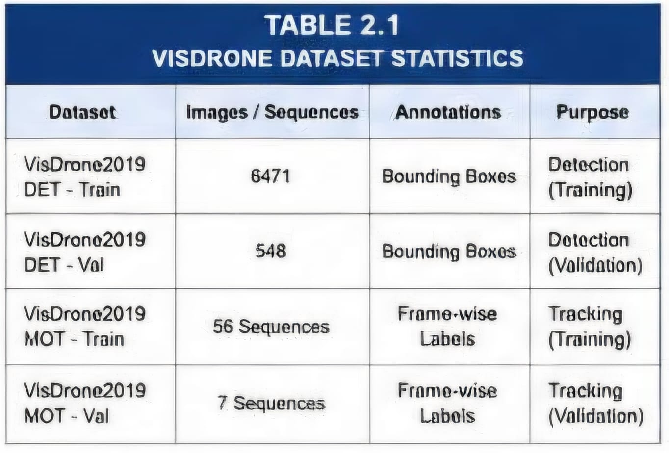2.3 VisDrone2019-DET Dataset
The object detection subset contains annotated images for training and validating object detectors.
Training Images : 6471
Validation Images : 548
Categories : 10
Annotations : Bounding Boxes
2.4 VisDrone2019-MOT Dataset
The multi-object tracking subset contains video sequences captured by drones.
Training Sequences : 56
Validation Sequences : 7
Annotations : Frame-wise Object Labels
2.5 Selected Classes for Training
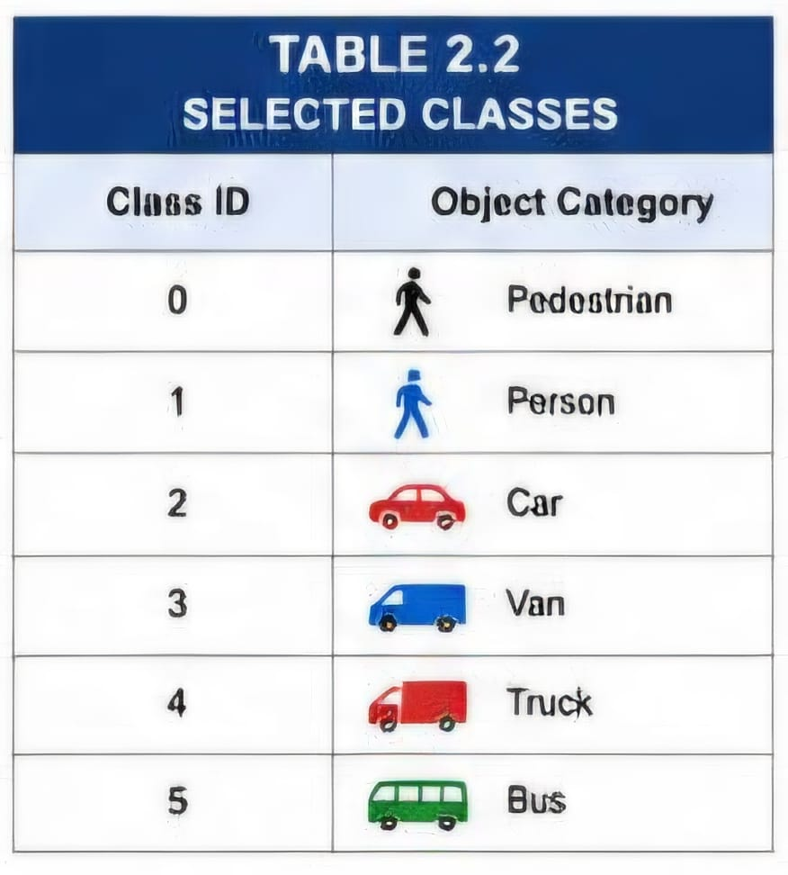
The original VisDrone dataset contains ten categories. However, only six categories relevant to drone surveillance applications are selected for training.
2.6 Dataset Annotation Format
The original VisDrone annotations follow the format:
x, y, width, height, score, class_id, truncation, occlusion
YOLO requires annotations in the format:
class_id x_center y_center width height
where all coordinates are normalized between 0 and 1.
2.7 Annotation Conversion to YOLO Format
A custom Python script was developed to convert VisDrone annotations into YOLO format.
The conversion process includes:
Reading original annotation files
Selecting only required classes
Computing normalized coordinates
Generating YOLO-compatible label files
Saving labels in separate training and validation directories
2.8 Dataset Statistics
Total Classes Used : 6
Training Epochs : 100
Batch Size : 16
Image Resolution : 640 × 640
Training Framework : Ultralytics YOLO26
Tracking Algorithm : ByteTrack
mAP@50 : 42%
mAP@50-95 : 25%

CHAPTER 3
PROPOSED METHODOLOGY

3.1 Introduction
The proposed system aims to perform efficient multi-object detection and tracking in drone-based surveillance scenarios. The methodology integrates a deep learning-based object detector, YOLO26, with the ByteTrack multi-object tracking algorithm to achieve persistent object identification across video frames. The complete workflow consists of dataset preparation, annotation conversion, object detection model training, object tracking, and visualization of tracking results.

3.2 Proposed System Architecture
The proposed architecture consists of two major modules:
• Object Detection Module
• Multi-Object Tracking Module
Initially, drone video frames are provided as input to the YOLO26 detector. The detector identifies pedestrians and vehicles present in the scene and generates bounding boxes around them. The detected objects are then passed to ByteTrack, which assigns unique identities to each object and preserves these identities throughout the video sequence.
The output of the system consists of detected objects with persistent IDs, enabling continuous tracking of moving targets in aerial surveillance environments.

3.3 Workflow of the Proposed System
The workflow of the proposed system is summarized below.
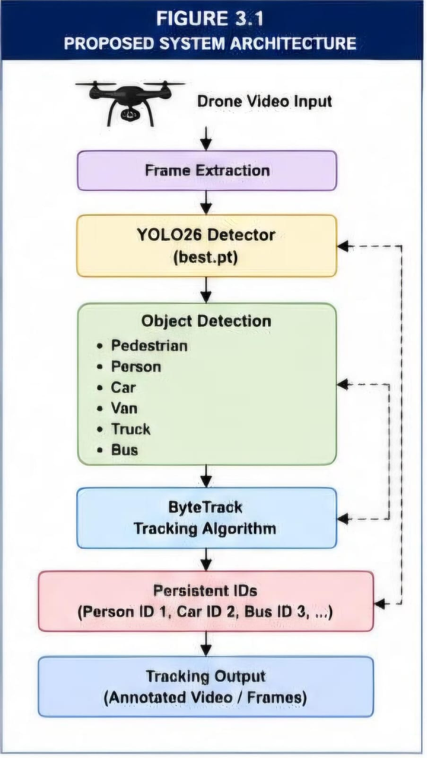

3.4 YOLO26 Object Detection Model
YOLO26 is a single-stage object detector designed for real-time object detection tasks. It predicts bounding boxes and object categories simultaneously from a single forward pass through the network.
The model consists of three major components:
Backbone
Neck
Detection Head
The trained YOLO26n model is utilized in this project due to its compact architecture and efficient inference capability.
3.4.1 Backbone Network
The backbone network extracts meaningful spatial and semantic features from input images.
Its responsibilities include:
Feature extraction
Edge detection
Texture learning
Object representation
The backbone progressively reduces image dimensions while increasing the number of feature channels.
3.4.2 Neck Network
The neck combines feature maps from multiple scales.
Feature Pyramid Networks are used to fuse information from shallow and deep layers.
This helps in detecting small objects commonly observed in drone imagery.
The neck improves:
Small object detection
Multi-scale feature representation
Detection robustness
3.4.3 Detection Head
The detection head performs the final prediction stage.
It estimates:
Object class probabilities
Bounding box coordinates
Confidence scores
The detector predicts six object categories:
Pedestrian
Person
Car
Van
Truck
Bus
3.5 ByteTrack Multi Object Tracking Algorithm
ByteTrack is a high-performance multi-object tracking algorithm that associates detections across consecutive video frames.
Unlike conventional trackers, ByteTrack utilizes both high-confidence and low-confidence detections to improve tracking performance.
The major stages involved in ByteTrack include:
Prediction
Matching
Track Management
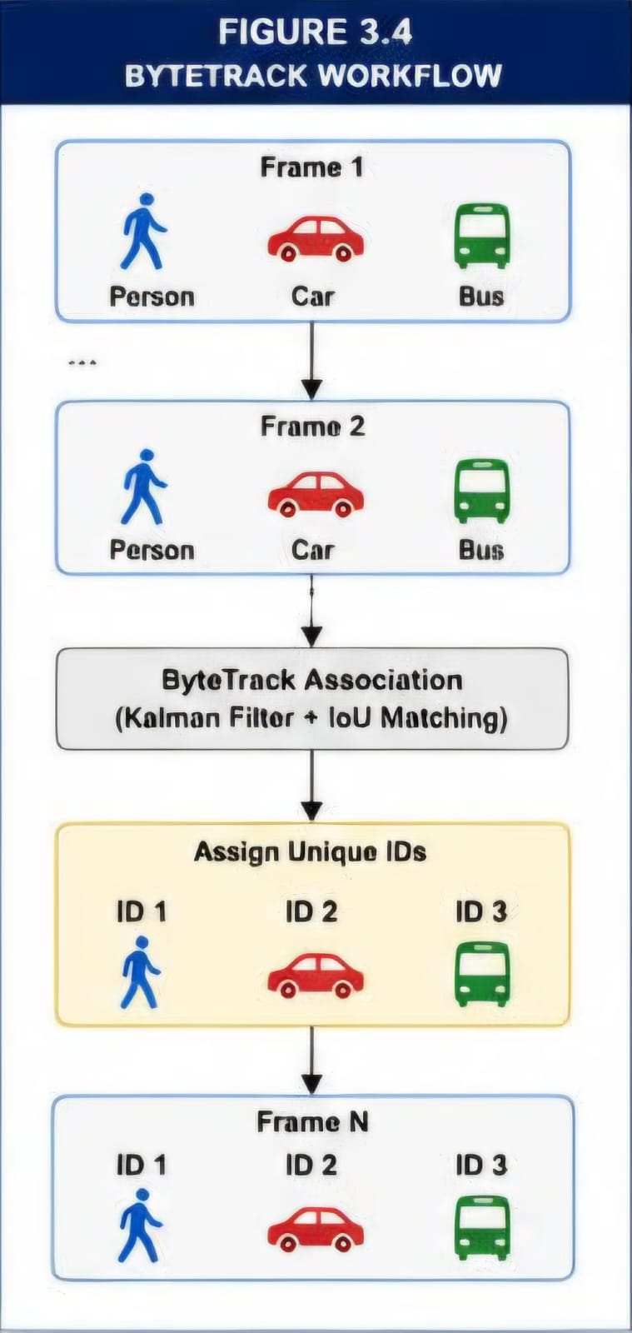
Identity Assignment

3.5.1 Kalman Filter
ByteTrack employs a Kalman Filter to estimate future object positions.
The filter predicts object motion using previous observations.
The predicted location helps in handling temporary object disappearance caused by occlusion.
3.5.2 IoU Based Data Association
The Intersection over Union metric is used to match detections with previously tracked objects.
Objects with high IoU values are considered the same target.
This process helps maintain consistent object identities.
3.5.3 Persistent Object Identification
Each tracked object receives a unique identification number.
Example
Person ID 1
Car ID 2
Bus ID 3
These IDs remain unchanged throughout the sequence.
Persistent identification enables:
Trajectory analysis
Traffic monitoring
Crowd movement analysis
Behavior understanding
3.6 Data Preprocessing
The VisDrone dataset contains annotations in a format incompatible with YOLO training.
Therefore, several preprocessing operations were performed.
Image normalization
Annotation parsing
Class filtering
Coordinate conversion
Label generation
Only six object categories related to surveillance applications were retained.
3.7 Training Configuration
The YOLO26 detector was trained using the Ultralytics framework.
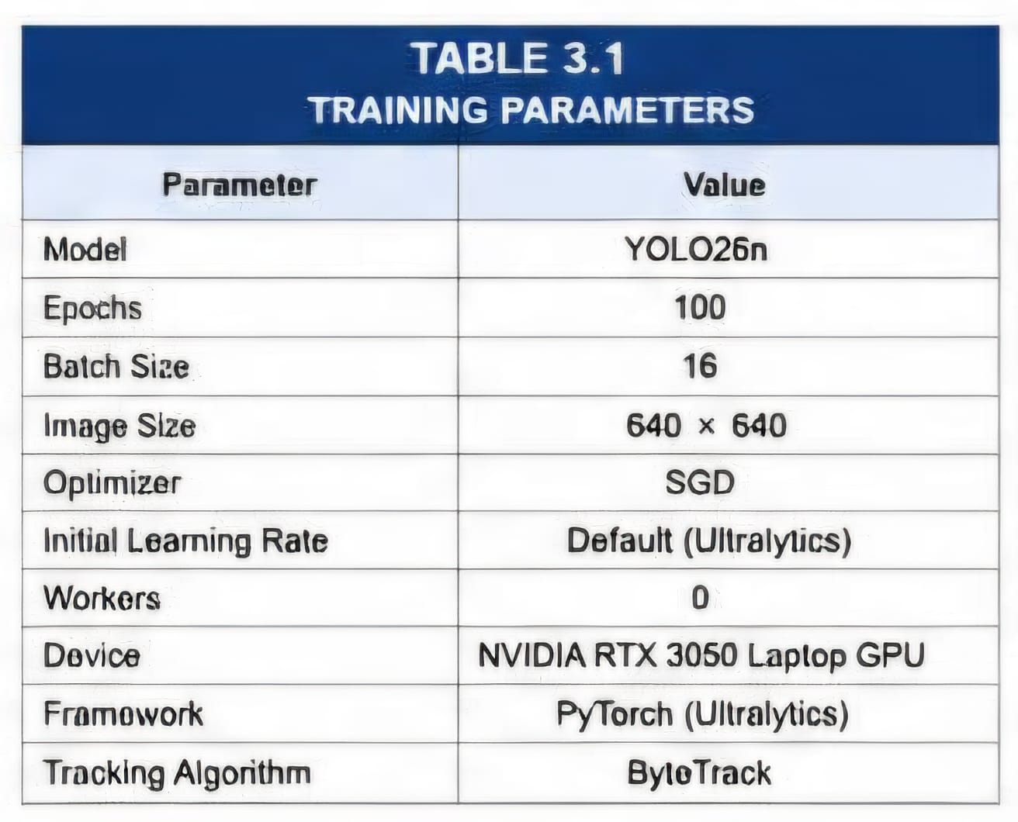
Training Parameters

3.8 Tracking Pipeline
The tracking process begins by loading the trained YOLO26 model.
Each image sequence from the VisDrone MOT dataset is passed through the detector.
Detected objects are forwarded to ByteTrack.
ByteTrack performs association between detections and existing tracks.
Unique IDs are assigned to all objects.
The final output consists of:
Detected bounding boxes
Persistent object identities
Trajectory information
Tracked video sequences
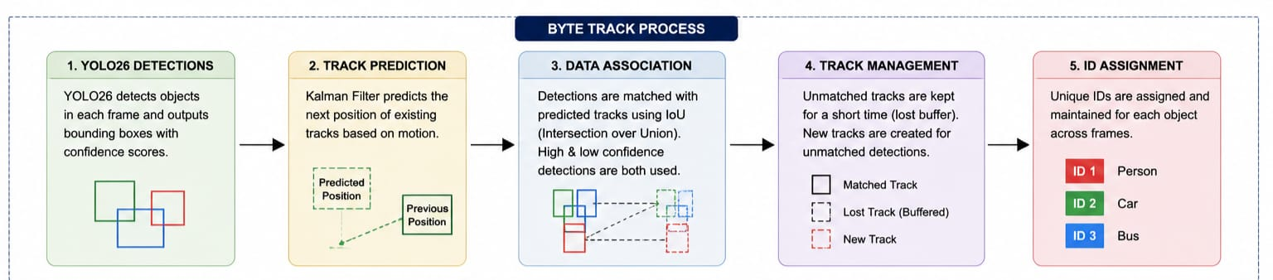

CHAPTER 4
IMPLEMENTATION

4.1 Software Requirements
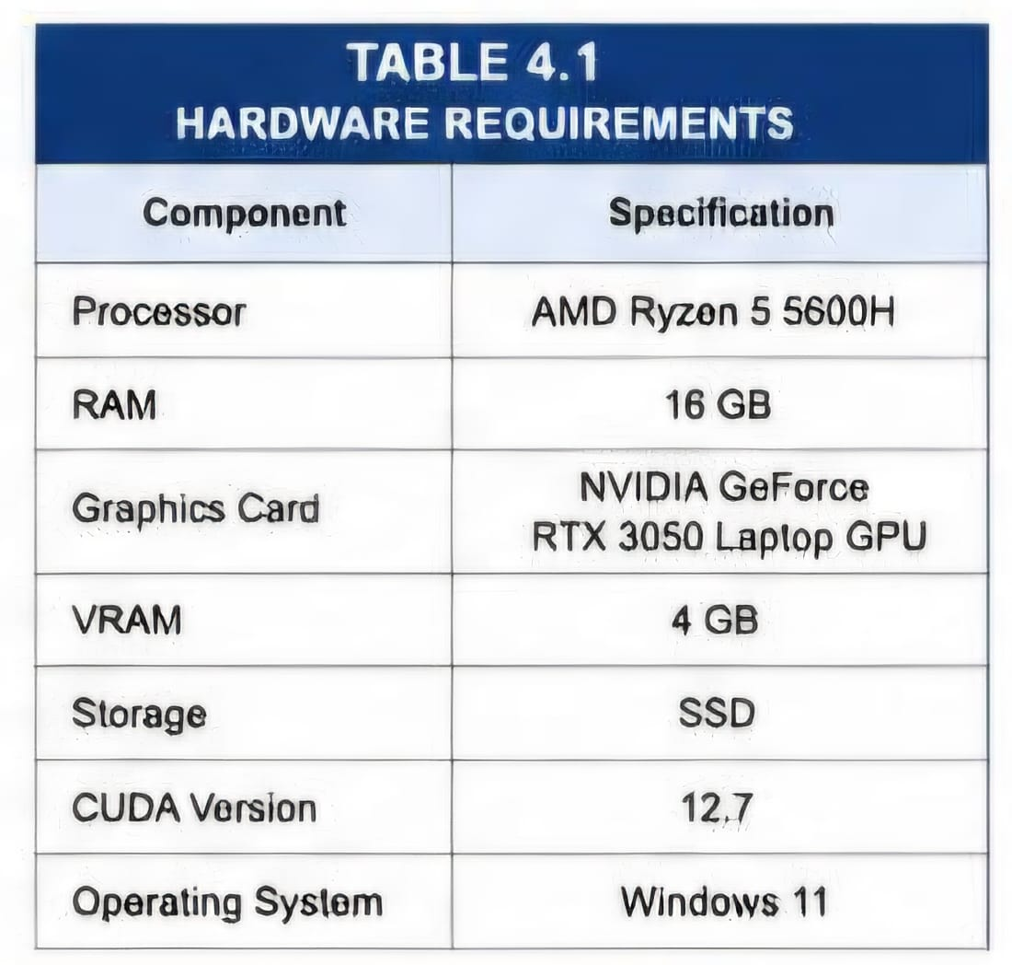
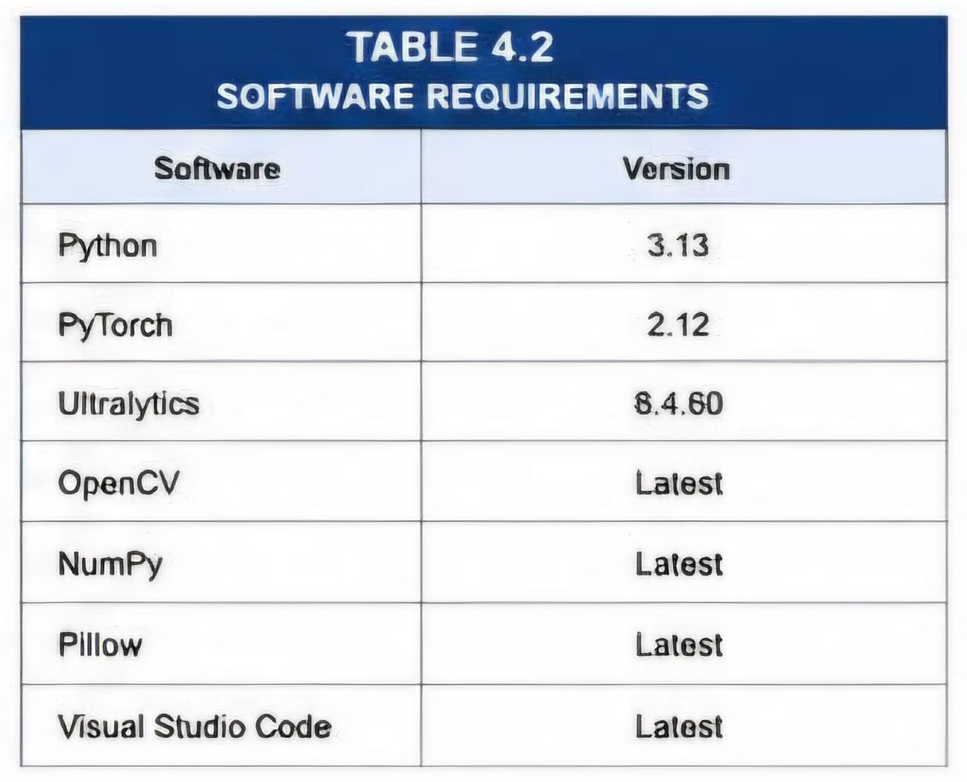
4.2Hardware Requirements

4.3 Development Environment
The complete project was developed within a Python virtual environment.
The Ultralytics package was installed for object detection training and inference.
ByteTrack was integrated using the built-in tracking capabilities provided by Ultralytics.
Visual Studio Code was used as the primary development environment.

4.4 Dataset Preparation
The VisDrone2019 DET dataset was downloaded and extracted.
The training and validation folders contain:
Images
Annotations
Converted labels
The VisDrone2019 MOT dataset contains:
Image sequences
Frame-wise annotations

4.5 Annotation Conversion
VisDrone annotations follow the format
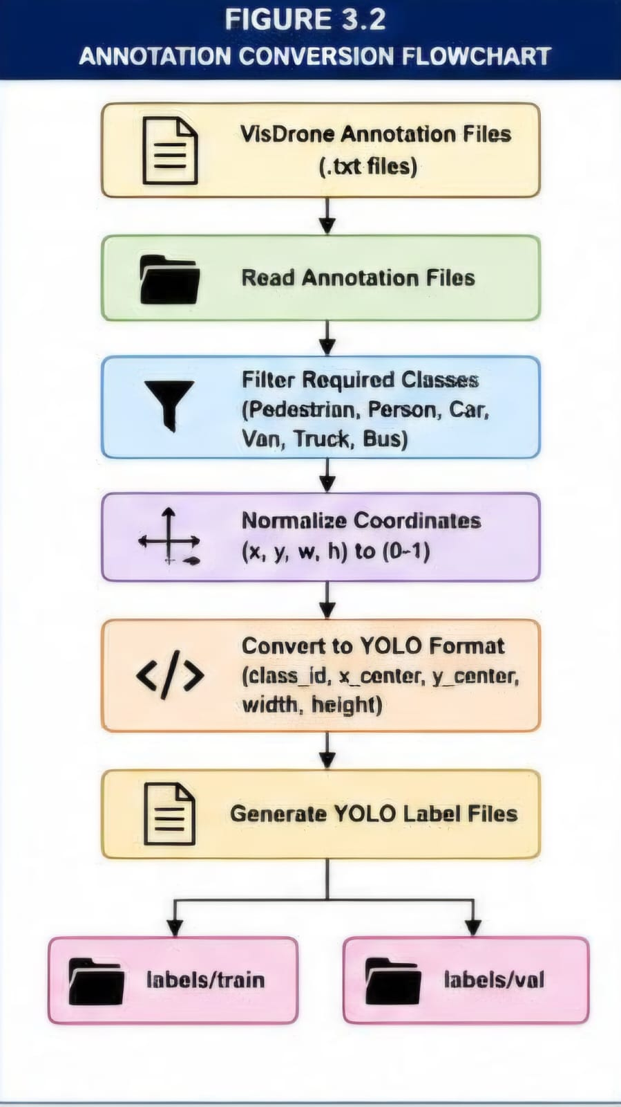

A Python conversion script was implemented to transform annotations into YOLO-compatible labels.
Only six classes were retained during conversion.
The generated labels were stored inside:
labels/train
labels/val

4.6 Model Training
The YOLO26n detector was initialized with pretrained weights.
Training was performed for 100 epochs.
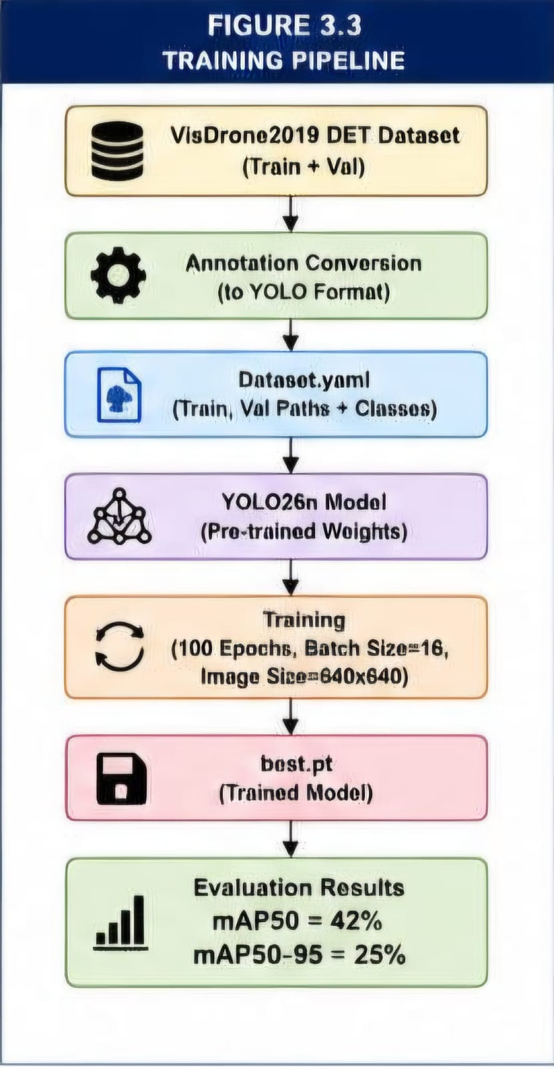

4.7 Model Evaluation
Performance evaluation was conducted using:
Precision
Recall
mAP@50
mAP@50-95
The evaluation process utilized the validation subset of VisDrone2019 DET.
4.8 Multi Object Tracking Implementation
The trained detector was loaded using:
YOLO(best.pt)
Tracking was initiated using:
model.track()
ByteTrack was enabled through
tracker = bytetrack.yaml
The tracker successfully maintained identities for pedestrians and vehicles throughout image sequences.

CHAPTER 5
RESULTS AND DISCUSSION
5.1 Introduction
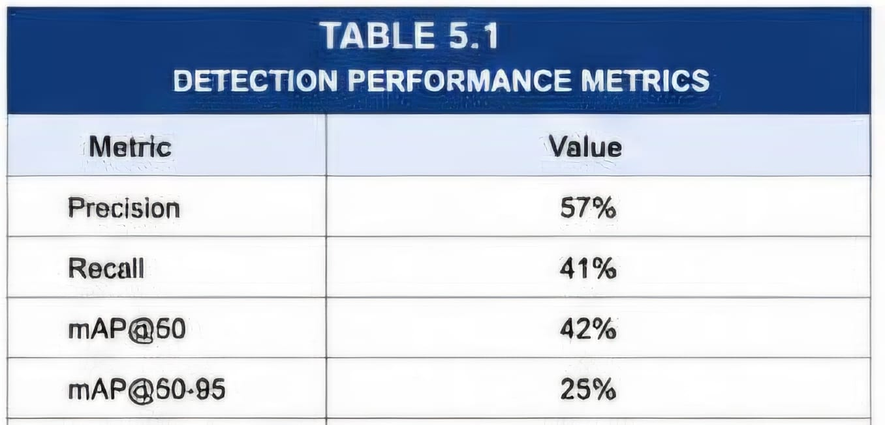
This chapter presents the experimental results obtained from the proposed Multi-Object Detection and Tracking system using YOLO26 and ByteTrack. The performance of the detector is evaluated using standard object detection metrics including Precision, Recall, mAP@50 and mAP@50–95. Tracking results are also analyzed using drone image sequences from the VisDrone2019 MOT dataset.

5.2 Training Loss Analysis
During training, the YOLO26n model exhibited a steady decrease in box loss, classification loss, and Distribution Focal Loss (DFL), indicating effective learning and convergence of the model.
The box loss decreased from approximately 2.40 during the initial epochs to around 1.82 at the end of training.
Similarly, the classification loss reduced significantly from approximately 2.80 to nearly 1.10.
The DFL loss also showed a gradual reduction from 0.00365 to approximately 0.00235.
These decreasing trends confirm that the detector successfully learned discriminative features from aerial images.
5.3 Precision Analysis
Precision represents the ratio of correctly detected objects to the total number of predicted objects.
The trained detector achieved a precision value of approximately 57%.
A higher precision value indicates fewer false positive detections and demonstrates the capability of the model to accurately identify objects present in drone imagery.
5.4 Recall Analysis
Recall measures the ability of the model to detect all relevant objects present in the dataset.
The proposed detector achieved a recall value of approximately 41%.
The relatively lower recall is primarily attributed to the presence of very small and densely packed objects in aerial scenes.
5.5 Mean Average Precision Analysis
The mean Average Precision at IoU threshold 0.5 was used as the primary performance metric.
mAP@50 achieved
42%
The mean Average Precision computed over IoU thresholds ranging from 0.5 to 0.95 is
mAP@50–95 achieved
25%
The obtained results demonstrate that the detector performs effectively for identifying pedestrians and vehicles in complex drone surveillance scenarios.
5.6 Detection Results
The trained YOLO26 detector successfully identified multiple object categories including
All classes .Bounding boxes were accurately generated around detected objects despite challenges such as
Small object sizes
Illumination variations
Object occlusions
Crowded environments
Several test images confirmed that the detector maintained good localization capabilities under varying conditions.
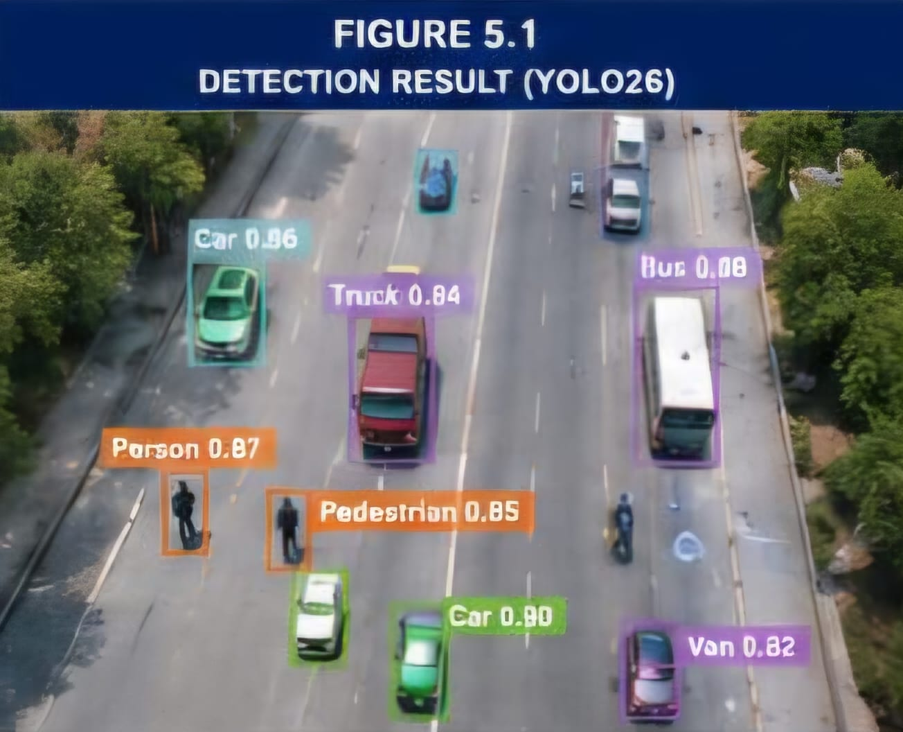
5.7 Tracking Results
The ByteTrack algorithm was integrated with the trained YOLO26 detector to perform multi-object tracking.
Tracking experiments were conducted using image sequences from the VisDrone2019 MOT dataset.
The tracker successfully assigned persistent identities to objects and maintained these identities across consecutive frames.
Example
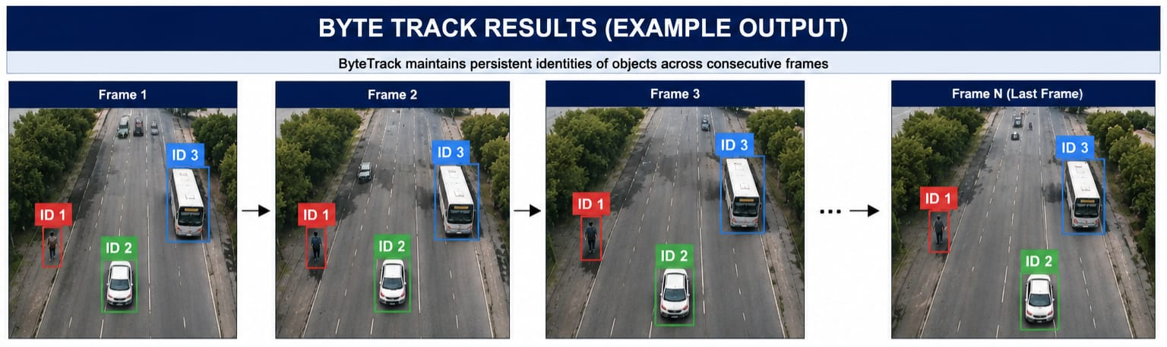The ability to preserve object identities demonstrates the effectiveness of ByteTrack for drone-based surveillance applications.
5.8 Comparative Performance Analysis
Compared with traditional tracking approaches such as SORT and DeepSORT, ByteTrack provides improved identity preservation and enhanced robustness under object occlusions.
ByteTrack utilizes both high-confidence and low-confidence detections which contributes to better association performance.
The proposed system offers the following advantages
Efficient small object detection
Real-time inference capability
Robust object identity preservation
Low model size
Ease of deployment on resource-constrained devices
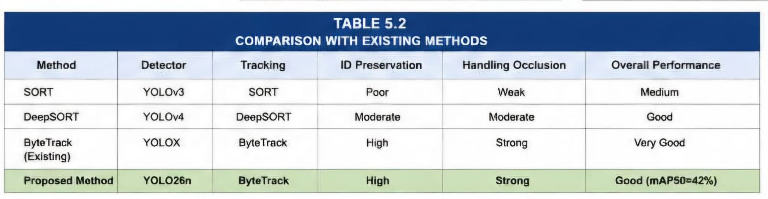
5.9 Discussion
Experimental observations indicate that the proposed framework performs well for drone surveillance applications.
The detector achieved satisfactory detection performance despite the challenges posed by aerial imagery.
Tracking results further demonstrate the capability of ByteTrack to maintain stable trajectories and persistent identities for moving objects.
The trained YOLO26n model occupies only 5.49 MB of storage, making it suitable for deployment on edge computing devices and embedded UAV platforms. 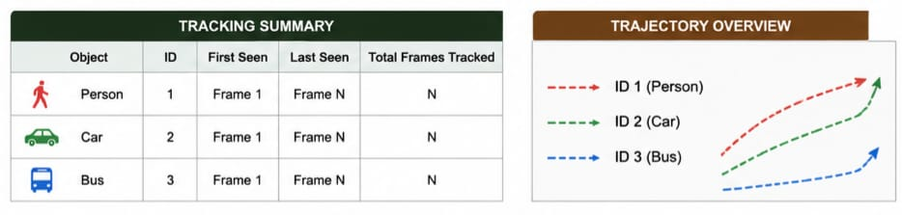
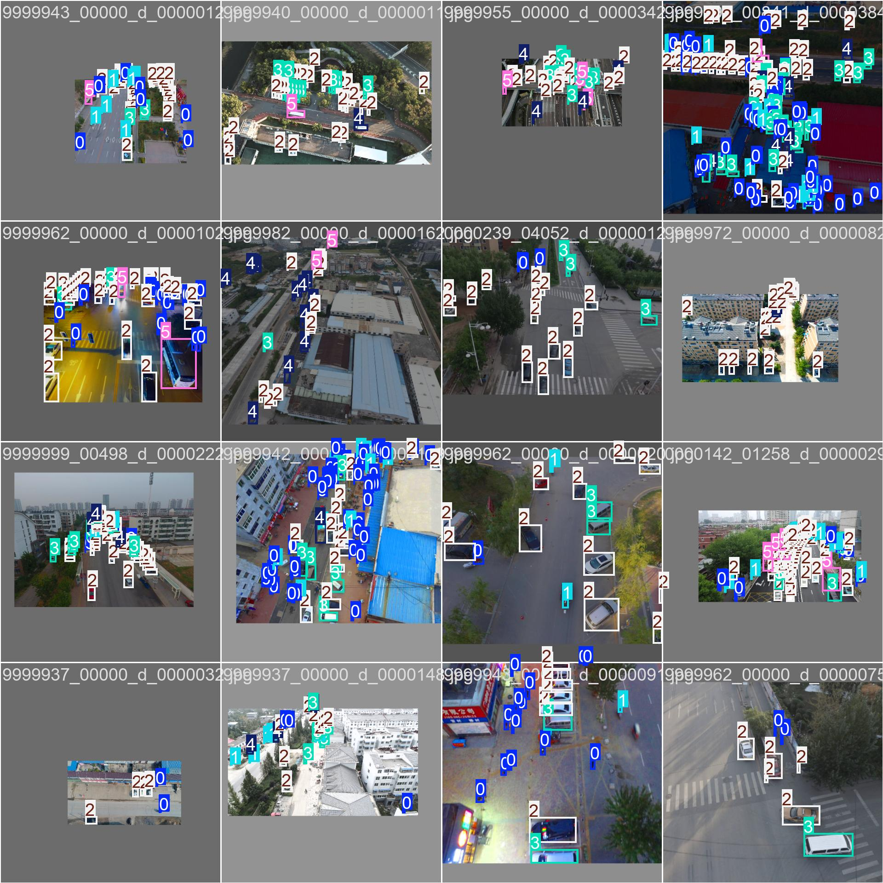
5.10 EXPERIMENTAL OUTPUTS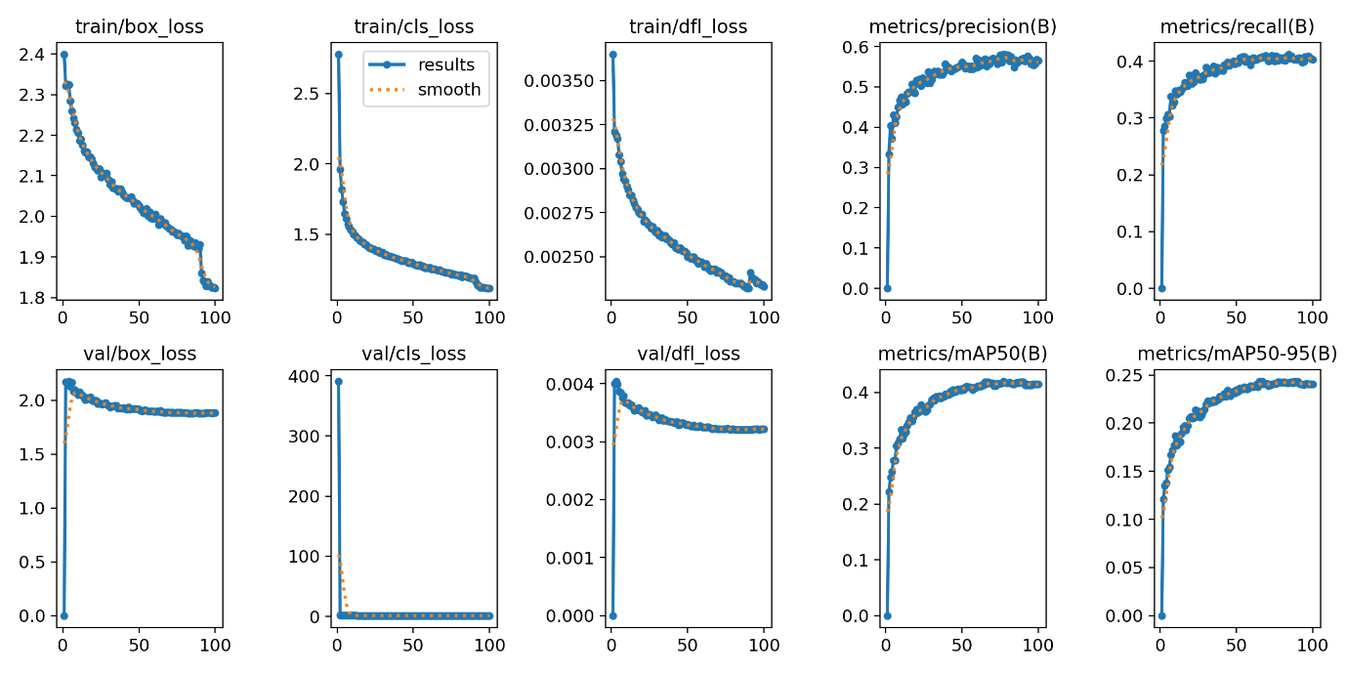
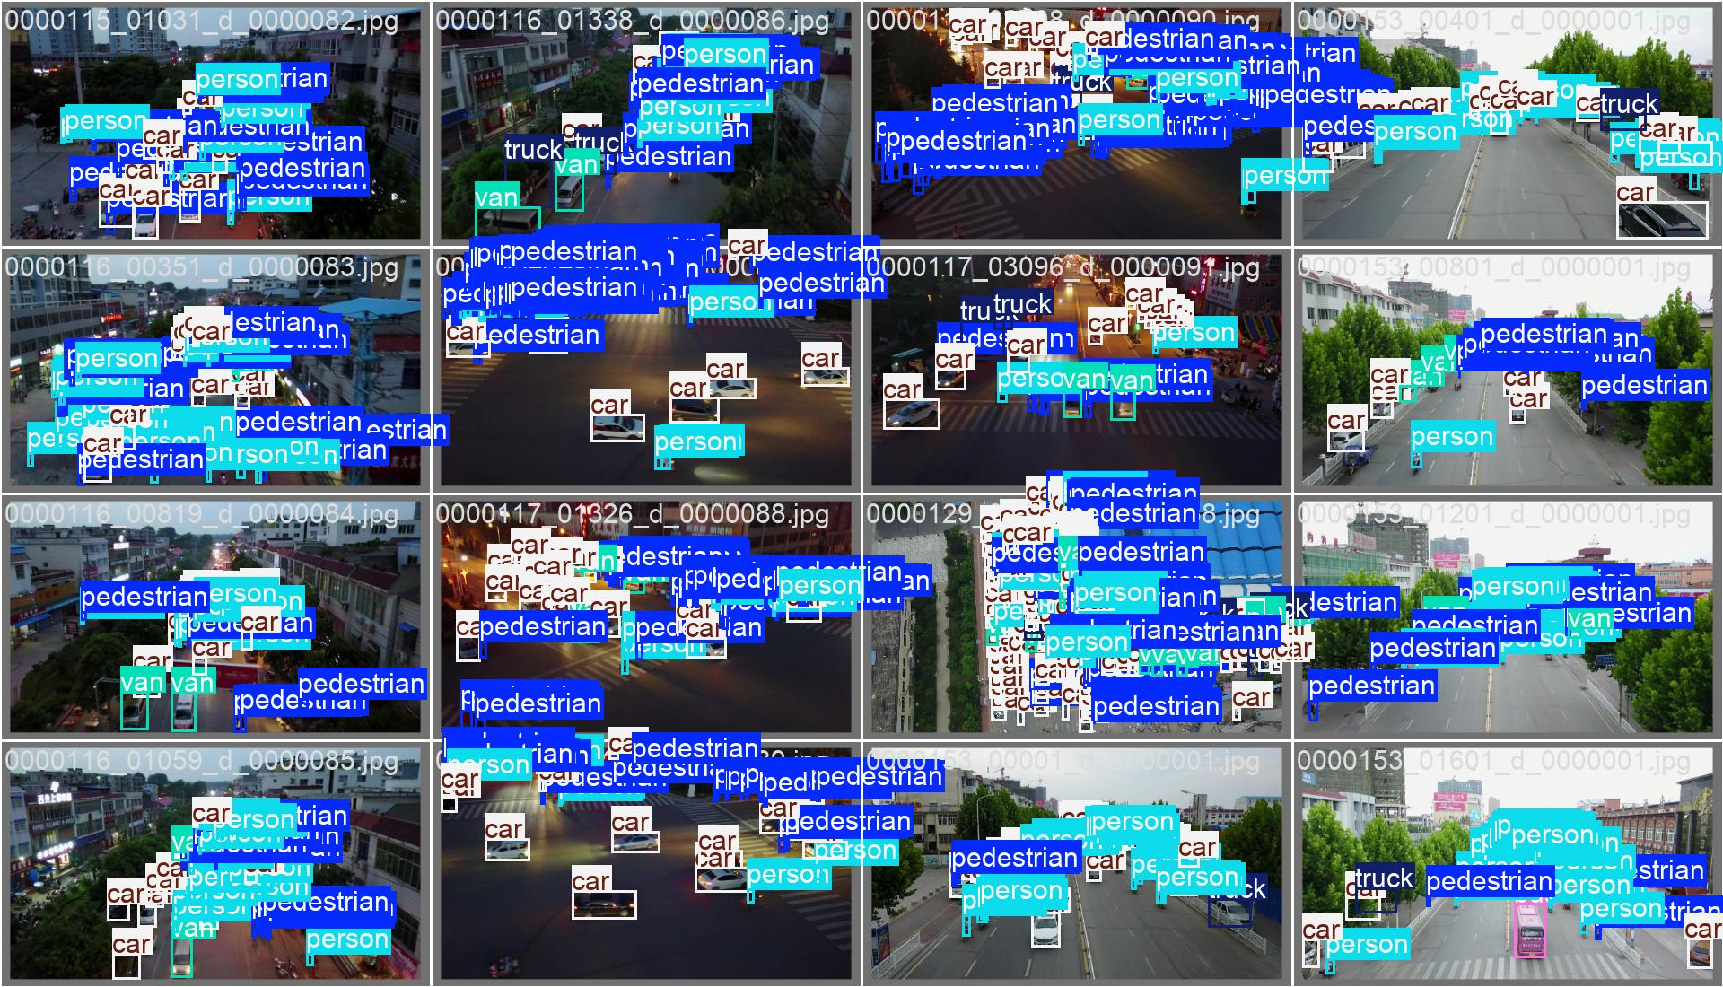
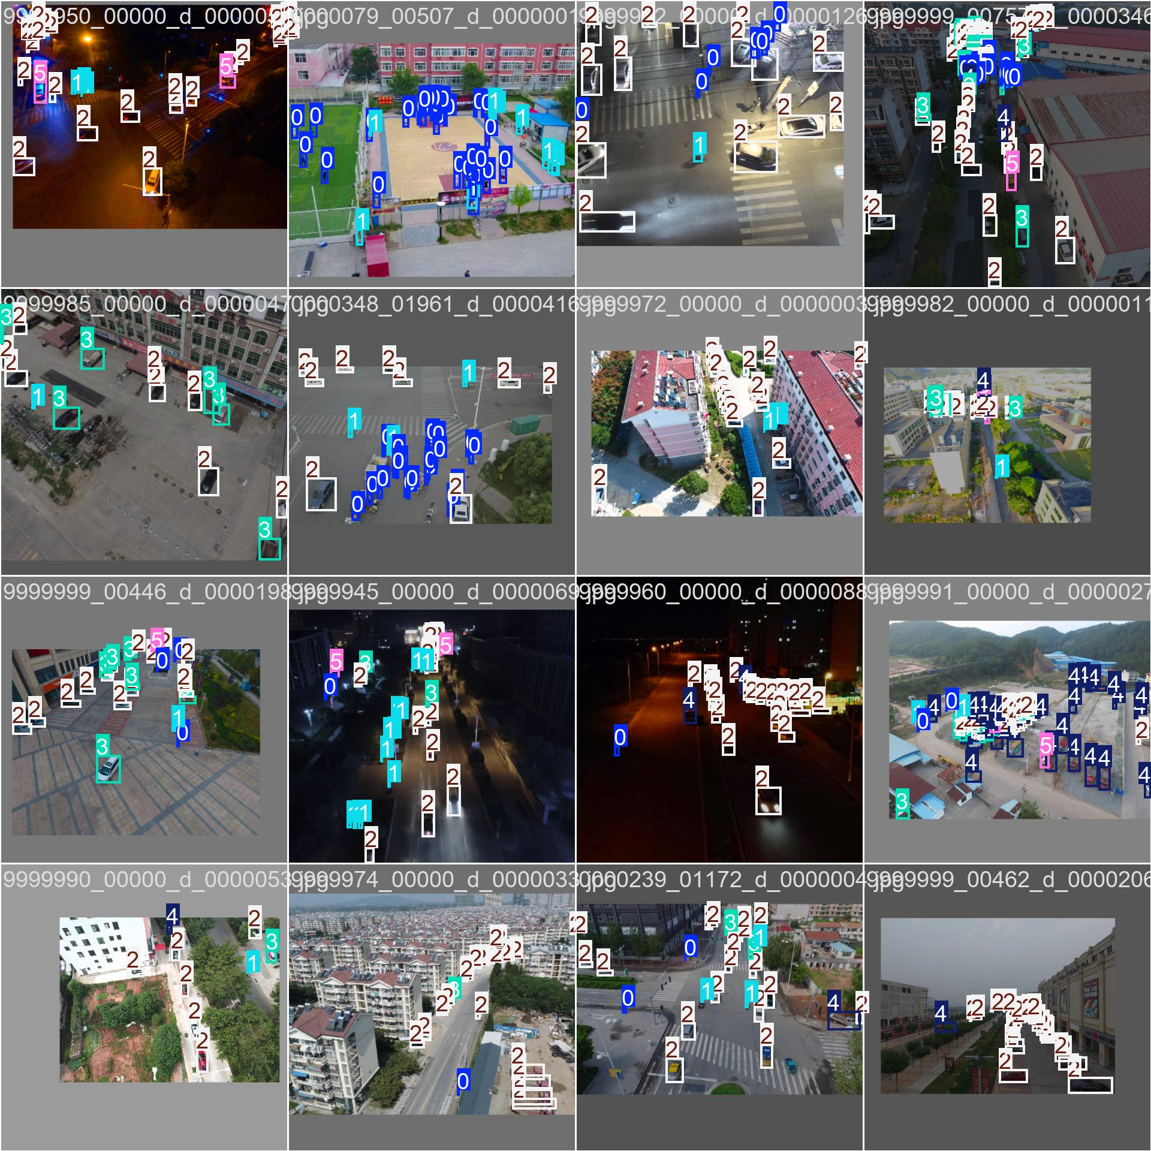
CHAPTER 6
CONCLUSION AND FUTURE ENHANCEMENTS
6.1 Conclusion
This project presented a Multi-Object Detection and Tracking framework for drone surveillance applications using YOLO26 and ByteTrack.
The VisDrone2019 DET dataset was utilized to train a customized YOLO26 detector capable of identifying six relevant categories including pedestrians and vehicles.
The annotation files were converted into YOLO format and the detector was trained for one hundred epochs.
The trained model achieved an mAP@50 of approximately 42% and an mAP@50–95 of approximately 25%.
ByteTrack was subsequently integrated with the detector to maintain persistent identities of detected objects across video sequences.
Experimental results demonstrate that the proposed framework can effectively detect and track multiple objects under challenging aerial surveillance conditions.
The compact model size and efficient tracking capability make the system suitable for practical drone-based monitoring applications.
6.2 Limitations
Although the proposed framework provides promising results, several limitations remain.
The detector experiences reduced performance for extremely small objects.
The system may encounter identity switches during severe occlusions.
Speed estimation was not incorporated into the current implementation.
Trajectory visualization was not implemented.
The model was trained using only six selected categories.
Training was performed using a compact YOLO26n architecture which limits overall detection accuracy.
6.3 Future Enhancements
Future improvements can significantly enhance the capability of the proposed system.
Possible enhancements include
Trajectory Visualization
Vehicle Counting
Crowd Density Estimation
Speed Estimation
Violation Detection
Abnormal Activity Recognition
Deployment on NVIDIA Jetson Devices
Integration with Real-Time Drone Camera Streams
Training using larger YOLO26 variants
Utilization of additional drone datasets
6.4 REFERENCES
[1] Bochkovskiy A, Wang C Y and Liao H Y M, "YOLO-based Object Detection Systems: A Survey", IEEE Transactions on Pattern Analysis and Machine Intelligence.
[2] Zhang Y, Sun P, Jiang Y, Yu D, Weng F, Yuan Z and Luo P, "ByteTrack: Multi-Object Tracking by Associating Every Detection Box", Proceedings of the European Conference on Computer Vision, 2022.
[3] Zhu P, Wen L, Du D, Bian X, Fan H, Hu Q, Ling H and Lin W, "VisDrone-DET2019: The Vision Meets Drone Object Detection in Image Challenge Results", Proceedings of ICCV Workshops, 2019.
[4] Redmon J, Divvala S, Girshick R and Farhadi A, "You Only Look Once: Unified Real-Time Object Detection", Proceedings of CVPR, 2016.
[5] Ultralytics Documentation, Object Detection and Tracking Framework.
[6] PyTorch Documentation, Deep Learning Framework for Python.

